Operating model for occupational health cooperation that supports mental health
A template for planning, implementing and assessing impactful activities
Instructions for using the template
- This template is a tool that workplace and occupational health care professionals can use to plan, implement and assess activities that promote mental well-being at the workplace.
- The information recorded in the template supports understanding the key themes that promote and challenge mental welfare that should be included in the occupational healthcare plan.
- Recording information regularly and clearly makes it easier to cooperate, come back to the issue later, monitor the activities and see what has been achieved and what has been successful.
Operating model for occupational health cooperation that supports mental health
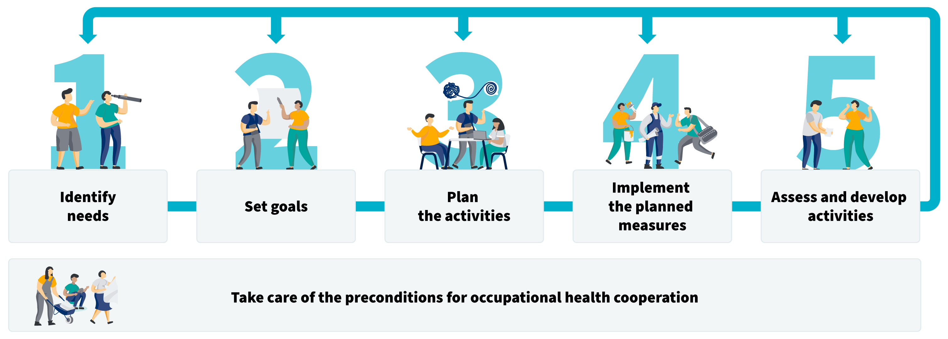

Step 1:
Identify needs

The purpose of this step of the operating model is to identify the needs for mental health support at the workplace.
- Collect information about factors and resources that cause strain at the workplace.
- Collect information from occupational healthcare using a workplace survey and other data collected by occupational healthcare.
- Together with the occupational healthcare provider, form a situational picture that indicates which factors supporting mental health and causing strain have been identified at the workplace.
- Use this situational picture as the basis of recording key needs for mental health support.

Task: Based on information collected at the workplace (e.g. from a risk assessment), what are the most important factors affecting mental health and the smooth running of work?
Enter your response here

Task: Based on the workplace survey carried out by occupational healthcare and other data sources (e.g. health examinations, health appointments, cooperation events), what are the most important psychosocial workload factors affecting mental health and the smooth running of work?
Enter your response here

Task: Which factors that put a strain on mental health should be addressed first?
Enter your response here

Task: Which resources must be strengthened?
Enter your response here

Step 2:
Set goals

The aim of this step of the operating model is to form a joint view between the workplace and occupational healthcare on the changes promoting mental health that the workplace is looking to achieve, and how they will be measured.
- Together with occupational healthcare, set clear and concrete goals for promoting mental well-being based on the needs for mental health support identified during the previous step.
- If necessary, break goals down into smaller sub-goals.
- Together, determine the indicators that enable the concrete assessment of the achievement of the goals and set a realistic timetable for achieving and monitoring the goals.
- Enter the goals, indicators and schedule in the fields below.

Task: Write down clear and concrete goals for the identified needs. If necessary, break the goals down into smaller sub-goals. If you want to pursue more than one need, you can copy the text on this page and create a thread for each need.

Need
Enter your response here

Goal
Enter your response here

Sub-goal 1
Enter your response here

Sub-goal 2
Enter your response here

Indicators that enable concrete assessment of goal achievement
Enter your response here

Timetable for goal achievement and follow-up time
Enter your response here

Step 3:
Plan the activities

The aim of this step of the operating model is to create a plan for concrete measures used to promote mental health at the workplace.
- Together with occupational healthcare, plan measures that are concrete and enable achieving the goals set. Put the measures in order of priority.
- Together, determine which representatives of the workplace and occupational healthcare participate in implementing the measures and the responsibilities of each party.
- Create a timetable for the measures.
- Set indicators that enable monitoring the implementation of the measures. Also set dates for the follow-up monitoring.
- Enter the measures that promote mental health in the fields below. They should also be included in the plan between the workplace and occupational healthcare.

Task: Copy the goals from the previous step and add them here. If you want to pursue more than one goal, you can copy the text on this page and create a thread for each goal.

Goal
Enter your response here

Measures
Enter your response here

Timetable
Enter your response here

Responsibilities
Enter your response here

Indicators
Enter your response here

Step 4:
Implement the planned measures

The aim of this step of the model is to ensure that the agreed measures to promote mental health are implemented as planned.
- Plan how information about the measures will be provided at the workplace.
- Check that supervisors and management promote and support the implementation of measures.
- Make sure that the persons responsible for the measures monitor the implementation of the measures and adherence to related timetables
- If the activities do not go as planned, stop and consider how the plan should be adjusted

Task: Copy the mental health promotion measures defined in the previous step and add them here.
Enter your response here

Task: How will you communicate about the measures?
Enter your response here

If you like, use this section to report if there is a need to change the plans
Enter your response here

Step 5:
Assess and develop activities

The aim of this step of the operating model is to regularly monitor and assess the implementation of the measures and objectives in cooperation with occupational healthcare.
- Together with occupational healthcare, assess the impacts of the measures taken to promote mental health at the workplace. How did the measures affect the goals set?
- Identify successes and development areas. How should the activities be modified or further developed?
- Based on this assessment, update the situational picture, goals and plan if necessary.

Task: Copy the previously defined goals and measures and add them here, and describe what you have achieved. If you want to pursue more than one goal, you can copy the text on this page and create a thread for each goal.

Goal
Enter your response here

Measures
Enter your response here

Were the planned measures implemented? What impacts did they have?
Enter your response here

How should the activities be modified or further developed?
Enter your response here

Further plan to support mental health
Enter your response here

